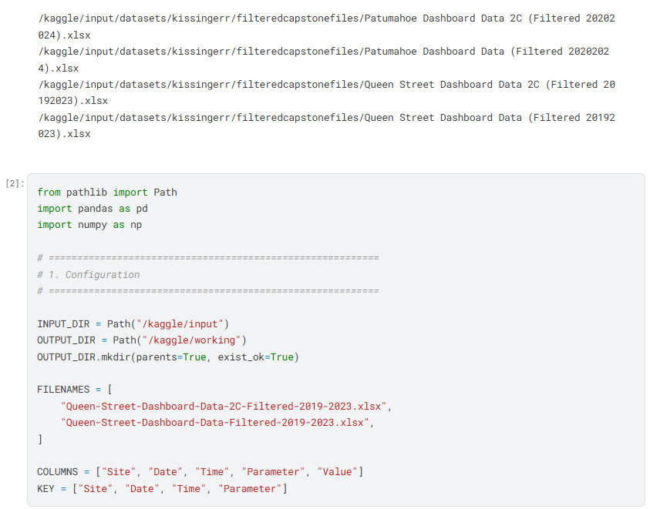

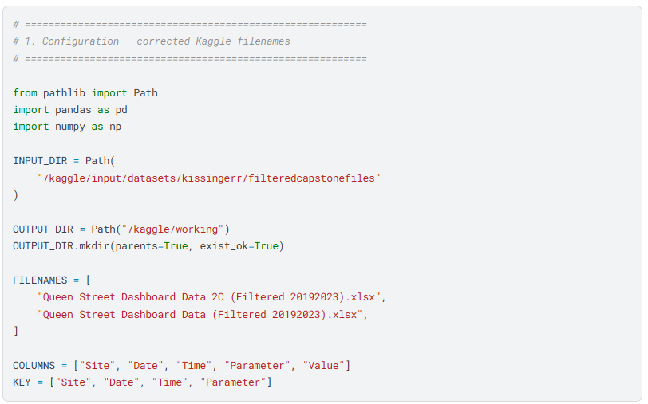

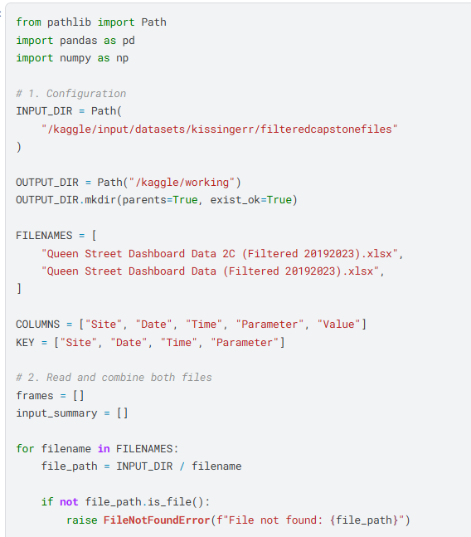

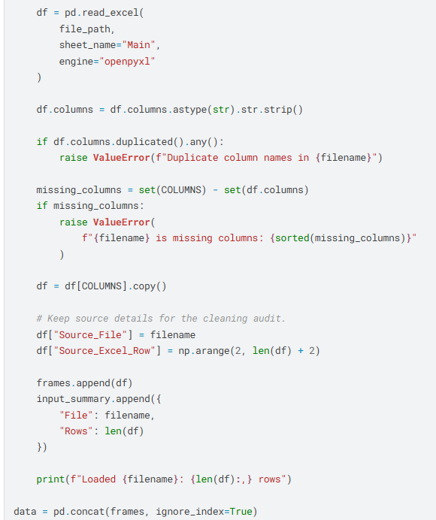

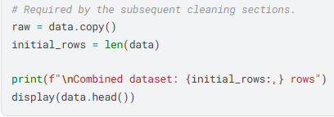

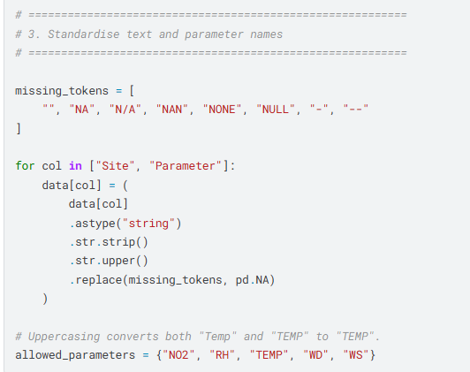

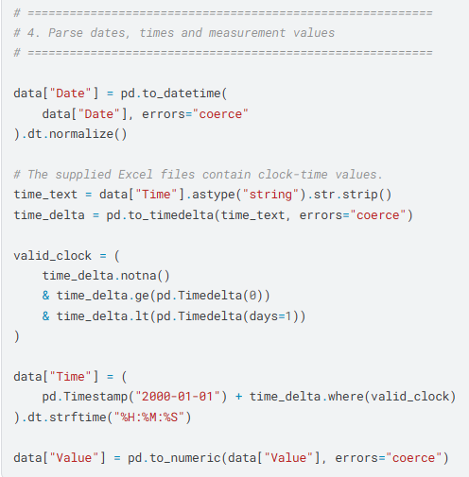

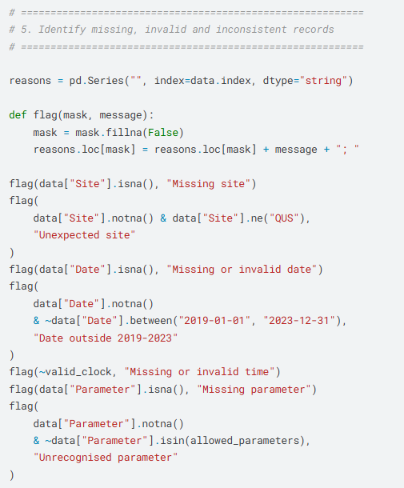

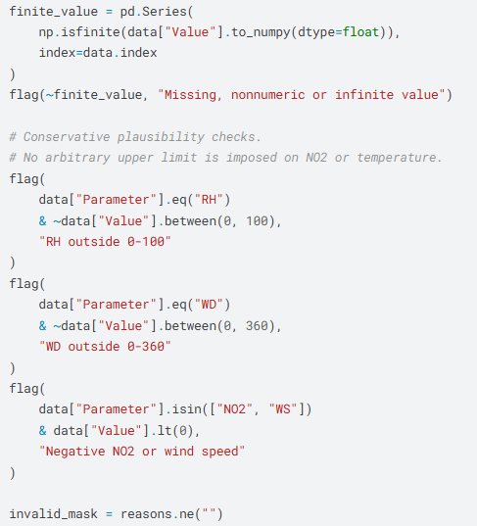

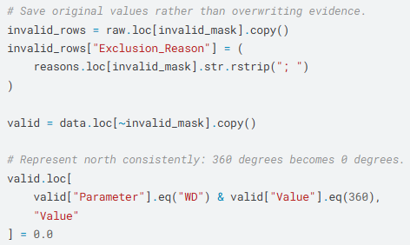

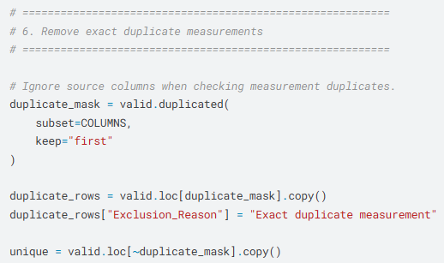

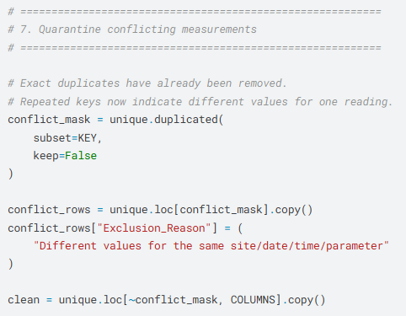

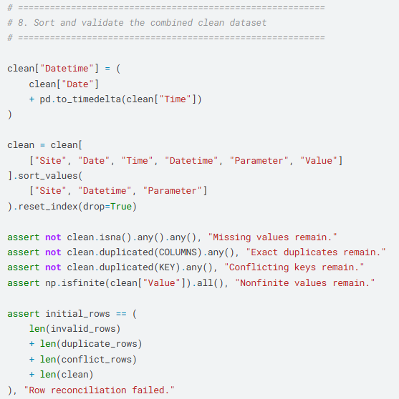

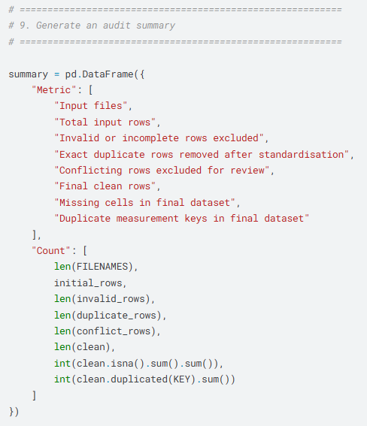

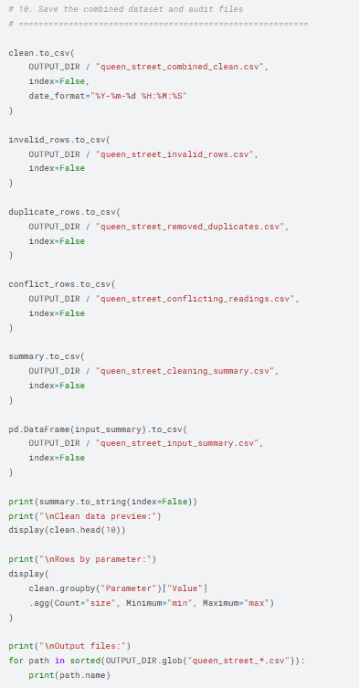

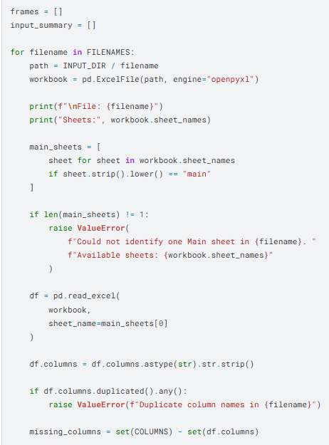

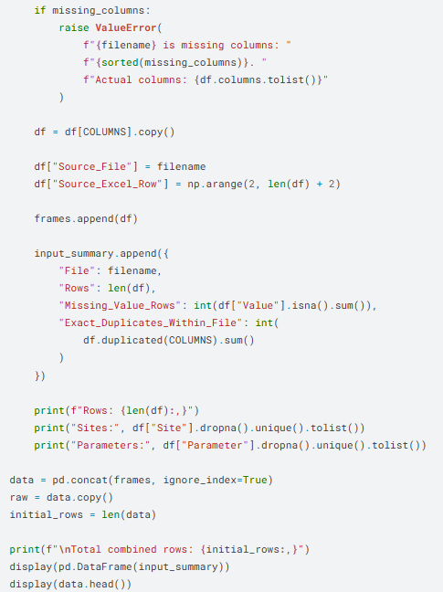

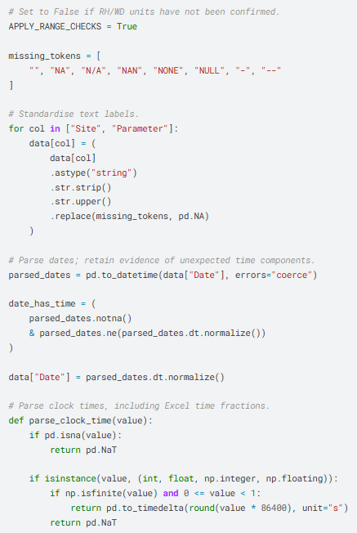

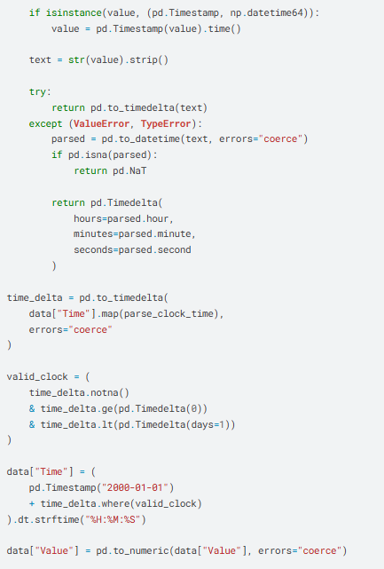

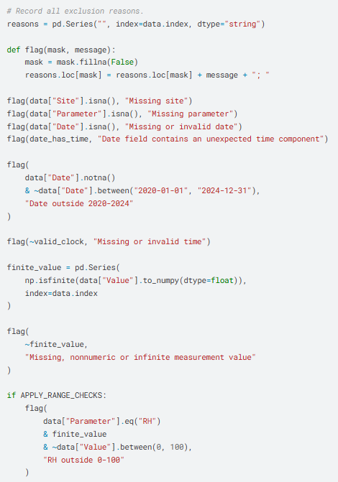

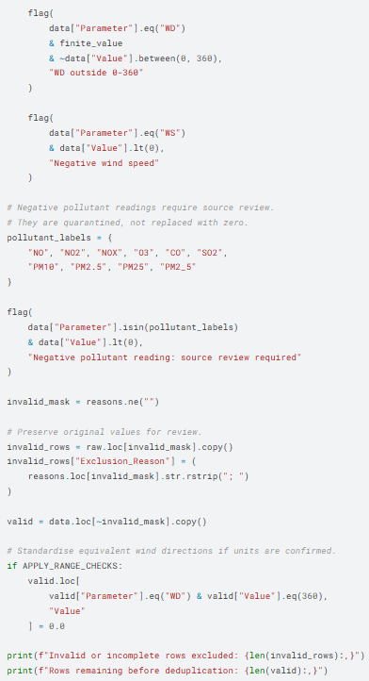

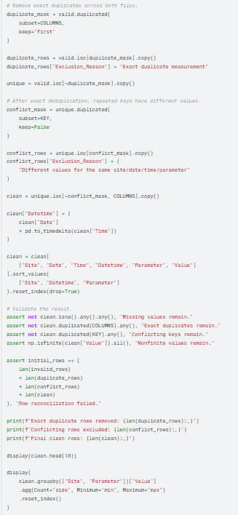

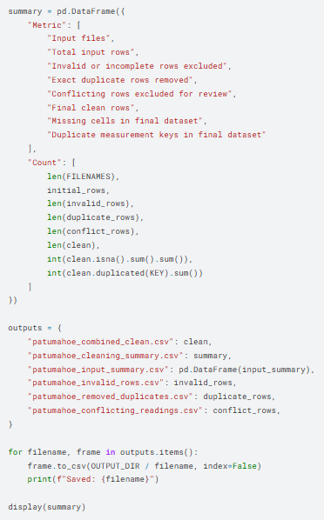

PATUMAHOE

Setup: import libraries and load the file
This cell:
- Finds the cleaned CSV.
- Checks required fields and duplicate measurement keys.
- Converts the long-format measurements into one column per pollutant.
- Inserts missing hours without estimating their values.
- Creates functions for saving tables and figures.
The complete hourly timeline is essential for lag analysis: one row must represent one hour, including hours with no measurement.

1. Dataset coverage and descriptive statistics
The dataset contains 100,312 measurement records from site PAT, covering 1 January 2020 to 30 April 2024. It contains no missing fields or duplicate timestamp–parameter keys, but some hourly measurements are absent from the timeline.patumahoe_combined_clean.csv
All concentrations below are reported in the file’s original numerical units. The CSV does not specify units, so these must be confirmed before comparison with health guidelines or regulatory standards.patumahoe_combined_clean.csv
Statistic | O₃ | NO₂ | Nox
Available hourly measurements | 34,634 | 33,026 | 32,652
Hourly coverage over the dataset period | 91.22% | 86.98% | 86.00%
Mean | 38.49 | 3.20 | 4.28
Median | 38.23 | 2.20 | 2.90
Standard deviation | 14.78 | 3.38 | 4.40
Minimum | 0.00 | 0.00 | 0.00
95th percentile | 63.02 | 9.80 | 12.80
99th percentile | 68.43 | 16.50 | 21.48
Maximum | 90.02 | 41.90 | 53.40
Calculated from the uploaded measurements. Coverage uses the complete hourly grid from the dataset’s first to last timestamp.patumahoe_combined_clean.csv
NO₂ and NOx have means noticeably above their medians, indicating right-skewed distributions with occasional high readings. O₃ has a mean close to its median. Zero readings are present; although they are not missing values, their validity should be checked against the source’s instrument and quality-control information.patumahoe_combined_clean.csv

2. Daily patterns
The hourly profiles show contrasting timing:
Pollutant | Lowest hourly mean | Highest hourly mean
O₃ | 31.07 at 07:00 | 49.02 at 14:00
NO₂ | Approximately 1.72 at 14:00–15:00 | 5.22 at 08:00
NOx | Approximately 2.50 at 14:00–15:00 | 6.99 at 08:00
These are pooled means by source clock hour, without timezone conversion.patumahoe_combined_clean.csv
Ozone rises through the morning and peaks in the afternoon, while nitrogen oxides peak in the morning and decline towards the afternoon. The observations establish contrasting daily profiles, but do not identify the contributions of emissions, atmospheric mixing, or chemistry.patumahoe_combined_clean.csv

3. Weekly patterns
Using daily means with at least 18 available hourly readings:
- NO₂ is highest on Thursday, at 3.88, and lowest on Sunday, at 2.22.
- NOx is also highest on Thursday, at 5.10, and lowest on Sunday, at 3.17.
- O₃ varies less across the week: approximately 38.06 on Tuesday to 39.37 on Sunday.patumahoe_combined_clean.csv
This suggests a clearer weekly pattern in nitrogen oxides than in ozone. However, these are descriptive comparisons—not tests showing that weekday differences are statistically significant or attributable to traffic.patumahoe_combined_clean.csv
The downloadable results include both the weekday summaries and the chronological weekly-mean series.

4. Seasonal patterns
The following are averages of eligible daily means, using Southern Hemisphere seasons.
Season | O₃ | NO₂ | NOx
Summer: December–February | 28.47 | 2.18 | 3.25
Autumn: March–May | 35.14 | 3.74 | 5.02
Winter: June–August | 46.03 | 4.27 | 5.30
Spring: September–November | 46.14 | 2.76 | 3.82
Calculated from days with at least 18 hourly observations for the relevant pollutant.patumahoe_combined_clean.csv
Two important findings emerge:
- O₃ is highest in spring and winter, not summer.
- NO₂ and NOx are highest in winter and lowest in summer.patumahoe_combined_clean.csv
Do not replace these findings with a generic expectation that ozone must peak in summer. They describe this dataset, although unequal seasonal coverage and the partial final year may influence the pooled means. The month-by-year plots in the supplied notebook help assess whether these patterns recur consistently.patumahoe_combined_clean.csv

5. Correlations between pollutants

Simultaneous hourly Pearson correlations
Variable pair | Pearson rrr | Paired observations
O₃–NO₂ | −0.407 | 31,013
O₃–NOx | −0.411 | 30,683
NO₂–NOx | +0.944 | 32,153
Correlations use timestamps where both measurements are available; missing hours were not filled.patumahoe_combined_clean.csv
Higher nitrogen-oxide readings tend to coincide with lower ozone readings. NO₂ and NOx are strongly positively associated, so treating them as independent predictors in a later model would require a multicollinearity check.patumahoe_combined_clean.csv

After removing typical month/hour patterns
Subtracting each variable’s average for its calendar-month/hour combination gives:
Variable pair | Adjusted Pearson rrr
O₃–NO₂ | −0.576
O₃–NOx | −0.540
NO₂–NOx | +0.940
These are correlations between departures from the typical month/hour pattern, not weather-adjusted correlations.patumahoe_combined_clean.csv
The negative ozone–nitrogen-oxide relationship therefore remains—and becomes stronger—after this temporal adjustment. It is not explained solely by the average daily and monthly cycles.patumahoe_combined_clean.csv

Meteorological correlations: a data limitation
Your Patumahoe file contains only O3, NO2, and NOX. It does not contain RH, TEMP, WD, or WS. The Queen Street file contains those meteorological variables, but they belong to another monitoring site.patumahoe_combined_clean.csv+1
Consequently:
- Patumahoe pollutant–weather correlations cannot be calculated from this CSV alone.
- Queen Street NO₂–weather correlations can be analysed separately.
- Joining Queen Street weather to Patumahoe ozone would be an explicitly cross-site analysis, not a same-site meteorological analysis.

6. Lagged relationships between NO₂ and O₃
I examined lags from −48 to +48 hours on a complete hourly grid, leaving missing measurements unfilled.
The strongest absolute correlation occurred at zero lag in all three versions:
Series analysed | Strongest lag | Pearson rrr
Original concentrations | 0 hours | −0.407
Month/hour-adjusted concentrations | 0 hours | −0.576
Hour-to-hour changes | 0 hours | −0.649
Calculated from overlapping observed measurements at each lag.patumahoe_combined_clean.csv
The strongest relationship in this search is therefore simultaneous, rather than a delayed response. Opposing hour-to-hour changes are especially pronounced. This does not establish that NO₂ causes an immediate ozone change, and weaker delayed associations may still exist. The full lag table is included rather than only the largest correlations.patumahoe_combined_clean.csv

7. Trends over the study period
I fitted daily-mean regressions with elapsed time and calendar-month indicators. Approximate 95% intervals use autocorrelation-robust standard errors with a 30-calendar-day setting.
Pollutant | Estimated change per year | Approximate 95% interval
O₃ | −0.176 | −0.829 to +0.477
NO₂ | +0.136 | −0.014 to +0.286
NOx | +0.333 | +0.068 to +0.599
Slopes are in the source concentration units per year. Eligible daily means require at least 18 hourly observations.patumahoe_combined_clean.csv
Under this model:
- O₃ has no clear linear trend because its interval includes zero.
- NO₂ also has an interval that includes zero.
- NOx shows a positive season-adjusted slope, with its interval above zero.patumahoe_combined_clean.csv
These are exploratory concentration trends, not evidence of changing emissions. The model does not adjust for meteorology, changes in monitoring practices, or all possible effects of missing data.
Also, do not compare the 2024 annual mean directly with complete years: the file ends on 30 April 2024.patumahoe_combined_clean.csv

8. Unusual pollution episodes and anomalies

Examples of high-concentration episodes
An episode is defined here as consecutive hours above the pollutant’s full-period 99th percentile.
Pollutant |  | Episode |  | Duration above threshold |  |  | Peak |  | Peak time
Pollutant | Episode |  | Duration above threshold |  | Peak | Peak time
O₃ | 30 October 2022 |  | 1 hour |  | 90.02 | 00:00
O₃ | 12 February 2020, 13:00–17:00 |  | 5 hours |  | 89.10 | 16:00
NO₂ | 3 March 2020 |  | 1 hour |  | 41.90 | 08:00
NO₂ | 24 June 2021, 19:00–23:00 |  | 5 hours |  | 38.10 | 22:00
NOx | 2 August 2022, 09:00–12:00 |  | 4 hours |  | 53.40 | 12:00
NOx | 15 June 2023, 08:00–11:00 |  | 4 hours |  | 52.60 | 10:00
These are relative high-concentration flags, not regulatory exceedances or confirmed pollution incidents.patumahoe_combined_clean.csv
The highest O₃ reading occurring at midnight is worth checking against the surrounding measurements, source timestamps, and instrument-quality information. Its timing alone does not establish an error.patumahoe_combined_clean.csv

Statistical anomaly screening
A separate screen compares measurements with their calendar-month/hour median using a robust median-absolute-deviation score. With an absolute score greater than 4.5 and at least 20 baseline observations, it flagged:
- O₃: 38 observations.
- NO₂: 454 observations.
- NOx: 580 observations.patumahoe_combined_clean.csv
These counts include unusually high and unusually low observations. They are review candidates, not records that should automatically be deleted. Groups with zero median absolute deviation were not scored.

QUEEN STREET

